Visual Reality

Adonia Jebessa, Ming Zeng, Sam Diener, Nicholas Bowling

*Introduction:*

This program seeks to use VR controls to create sandbox for the intuitive design of 3D environments. Users can use this tool to manipulate and interact with dynamic 3D objects. Users move and scale their own avatar to get a better view of whatever they are creating. Objects have options to enable physics so to give players more options in interaction.

*Installation Guide:*

This program was developed to run on Unity using an Oculus Quest device. The program is implemented using OpenXR and all XR acceptable devices can be used. The repo can be downloaded from github at https://github.com/AdoniaJ1/VisualReality.

*User Guide/Mechanics:*

* **Object Grabbing**
  + Upon pressing the grab button, the user will grab the nearest object.
* **Movement & Teleportation**
  + Users can use the two joysticks to move their avatar.
    - The left joystick will cause the user to move directly in whatever direction is pressed.
    - The right joystick will move the player if pressed forwards or backwards but will rotate the player if pressed left or right.
  + Upon pressing the button “A” or “X”, a circular indicator will appear in the direction the user is pointing the controller. When the user releases the button “A” they will be teleported to the location of the indicator.
* **Object Spawning**
  + Upon pressing the “B” button, the user will spawn an object according to what object he/she selects in the menu.
  + An object in the environment can be set as the new spawn object by selecting the “Set as Spawn” button from the object menu.
* **Object Scaling**
  + To scale a grabbed object, the user can hold the Trigger button of whatever controller they are grabbing the object with. This will cause the object to freeze in place and moving the hand along the y, x or z axis will cause the object to scale in these directions.
  + Object scale can also be altered in the object menu.
* **Physics**
  + Players can change 3 physics properties associated with any spawned object by setting associated toggles on the object menu.
    - Gravity: When enabled, object will fall downwards until they impact with another object with collision.
    - Throwable: When enabled, the object will maintain velocity when released from a grab.
    - Collision: When enabled, the object will collide with the floor, walls, and other objects with collision enabled.
* **Object Color**
  + Players can change the color of objects with a dropdown menu on the object menu.
* **Player Scaling**
  + Players can increase or decrease the size of their avatar by pressing ‘+’ or ‘-’ on the player menu attached to the left wrist.
  + This will also affect the force of throws.
* **Scene Controls**
  + Players can reset scenes to their original state by pressing ‘Reset’ on the player menu attached to the left wrist.
  + Players can change scene by pressing ‘Scene Select’ on the player menu attached to the left wrist.

***Control Diagram:***

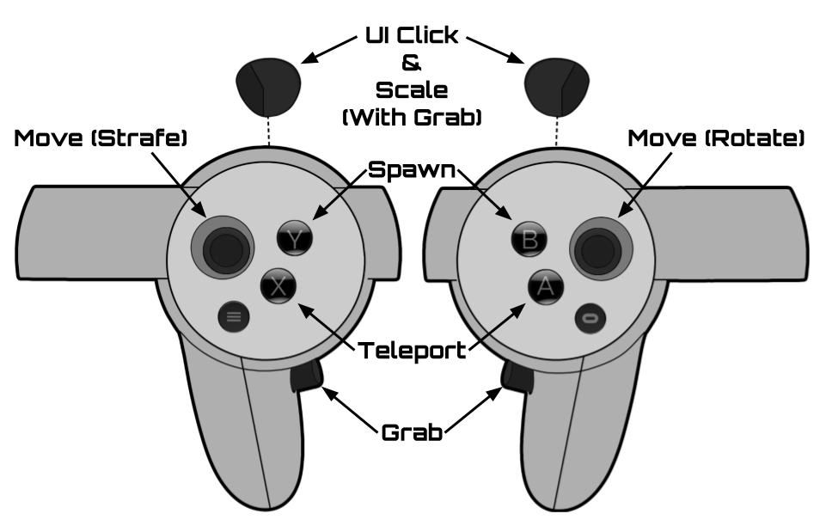

***Object Menu Description:***

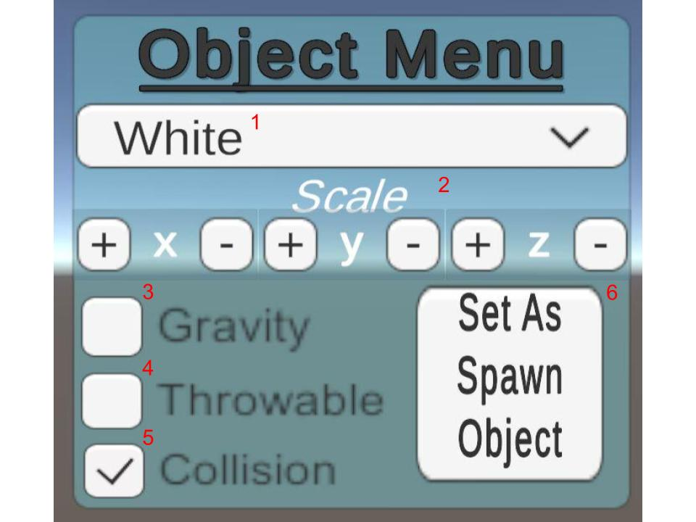

1. **Color Selector**: Selecting a color from the dropdown will change the color of the object.
2. **Scale Controls**: Adding or subtracting will change x, y, or z scale without grabbing.
3. **Gravity**: Toggles gravity on the object.
4. **Throwable**: Toggles whether an object will maintain momentum when released.
5. **Collision:** Toggles collision on the object.
6. **Set As Spawn Object**: Sets the object to be copied when pressing the spawn button.

***Player Menu Description***

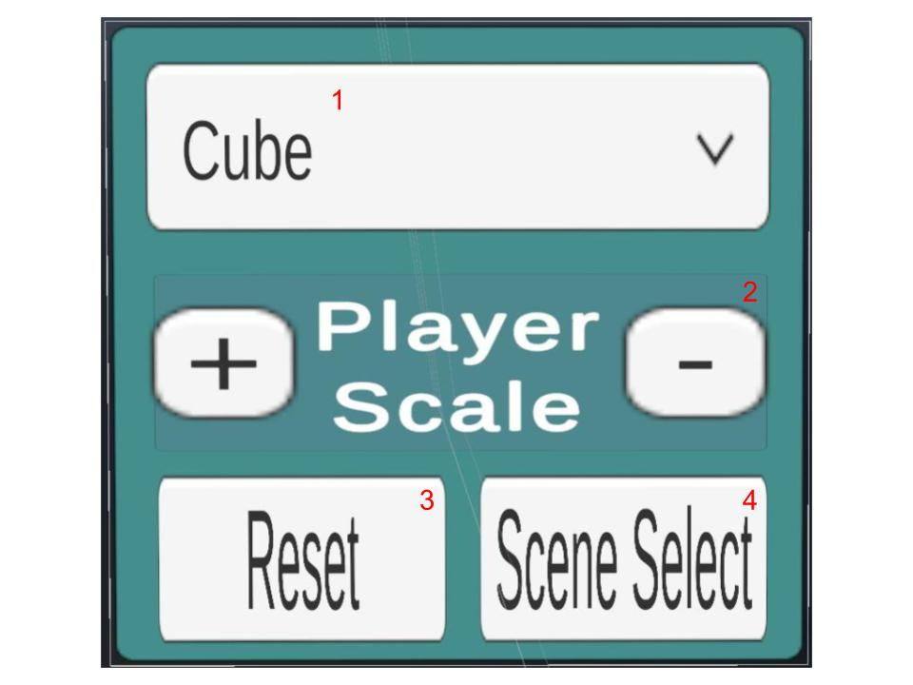

1. **Object Selector**: Selecting a shape from the dropdown which shape is made with the spawn button.
2. **Player Scale**: Increments or decrements avatar size.
3. **Reset**: Resets the scene to its original state.
4. **Scene Select**: Returns player to the Start Menu.

***Start Menu Description***

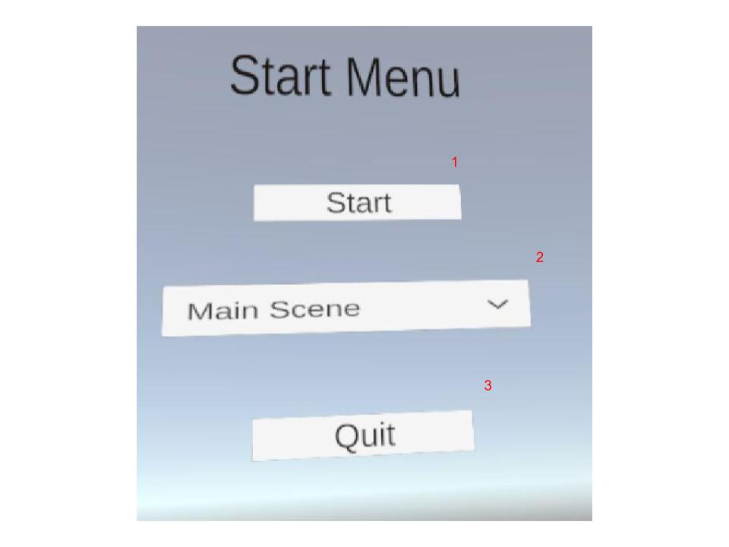

1. **Start**: Loads the selected scene.
2. **Scene Selector**: Selecting a scene from the dropdown will cause that scene to be loaded when start is pressed.
3. **Quit**: Closes the game.

***FAQ’s:***

* Is there any limit to how many items can be made?
  + Theoretically some number of objects may cause slowdown, but we haven’t been able to reach that number during testing.
* Why isn’t the UI working when I release the pointer?
  + The ui is set to respond when a button is clicked. This means that the ui click button must be released shortly after it is pressed. Try pressing the button a few times and you should get the timing.
* Can I use this software with my headset?
  + This software is developed using openXR. The following devices have been confirmed to work: Windows Mixed Reality (eg: HP Reverb, Samsung Odyssey), Oculus Quest & Quest 2, Pimax 5K & 8KX, Varjo Aero & VR-3, Valve Index, HTC Vive, HTC Vive Cosmos, Pico Neo 3 & 4.
  + Consult this page for more details: [https://mbucchia.github.io/OpenXR-Toolkit/#:~:text=The%20application%20must%20use%20OpenXR,%2C%20 Pico%20Neo%203%20%26%204](https://mbucchia.github.io/OpenXR-Toolkit/#:~:text=The%20application%20must%20use%20OpenXR,%2C%20Pico%20Neo%203%20%26%204).